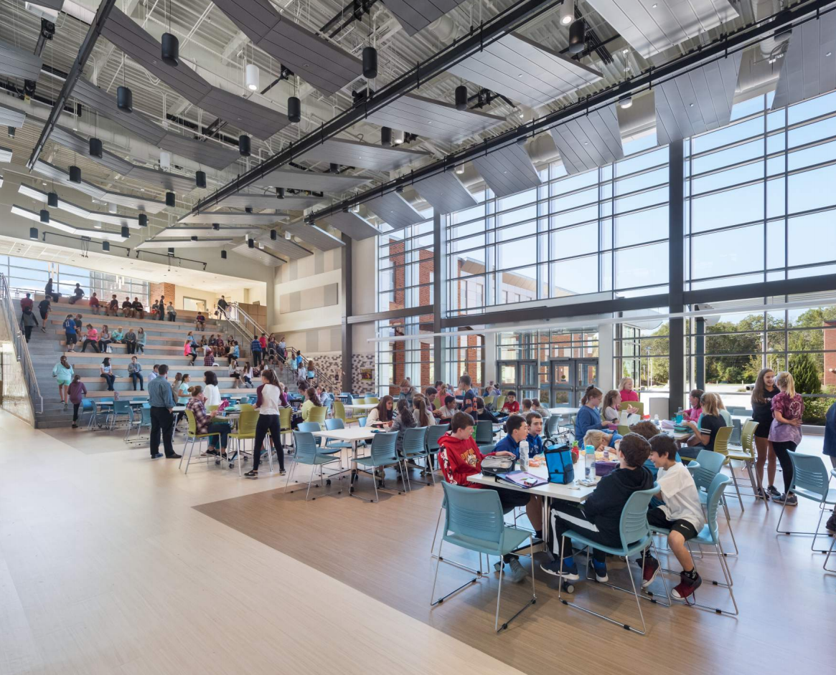

-------------------------------------

Massachusetts School Furniture Exhibition

2020

-------------------------------------

Thursday, May 7th

10:00 AM – 5:00 PM

DCU Center North Exhibit Hall

50 Foster St, Worcester, MA

**Calling all School District Personnel, Procurement Officers, Architects, and Designers!**

**Massachusetts is currently undertaking approximately $1B worth of school construction per year in the public K-12 market with a combination of a state-funded grant program and local funding.**

**The 2nd annual exhibition hosted by the Association for Learning Environments (A4LE) Northeast Region is a one stop showing of the latest school furniture products from furniture manufacturers and furniture dealers.**

**Admission to attend the event is FREE to all school personnel, public officials, and members of the design community. The format is open house … visitors come and go over the course of the day.**

**Exhibitors interested to reserve a booth must register and pay a fee. Click** [**here**](https://www.a4le.org/A4LE/Contacts/Sign_In.aspx?ReturnUrl=%2FA4LE%2FContacts%2Fhlloginredirect.aspx%3FRedirect%3Dhttps%253a%252f%252fmembersforum.a4le.org%252fhome) **to register.**

**For more information please visit A4LE’s** [**website**](https://www.a4le.org/A4LE/Events/Event_Display.aspx?EventKey=MASFURN20&WebsiteKey=d37387ab-a51a-4aef-8403-8eaa70ea95e2) **or contact Carla Cummins at carla@a4le.org**

LESTER J. GATES MIDDLE SCHOOL

Scituate Public Schools

Scituate, MA